**DAILY ONLINE ACTIVITIES SUMMARY**

|  |  |  |  |  |  |  |
| --- | --- | --- | --- | --- | --- | --- |
| **Date:** | | **02/07/2020** | **Name:** | | **KHATHEEJA SAFREENA.** | |
| **Sem & Sec** | | **4th SEM 'A' Section** | **USN:** | | **4AL18CS037.** | |
| **Online Test Summary** | | | | | | |
| **Subject** | N/A | | | | | |
| **Max. Marks** | N/A | | | **Score** | N/A | |
| **Certification Course Summary** | | | | | | |
| **Course** | | **FUNDAMENTALS OF DIGITAL MARKETING.** | | | | |
| **Certificate Provider** | | **Google digital garage.** | | **Duration** | | **40 hour** |
| **Coding Challenges** | | | | | | |
| **Problem Statement:** 1.Given a non-decreasing array arr[] and an integer K, the task is to remove K elements from the array such that maximum difference between adjacent element is minimum.  .  For example | | | | | | |
| **Status: completed** | | | | | | |
| **Uploaded the report in Github** | | | | **Yes** | | |
| **If yes Repository name** | | | | **[http://shafreenasharief / lockdown-coding](http://shafreenasharief / lockdown-coding" \o "http://shafreenasharief / lockdown-coding)** | | |
| **Uploaded the report in slack** | | | | **Yes** | | |

Certification Course Details: (Attach the snapshot and briefly write the report for the same)

Coding Challenges Details: (Attach the snapshot and briefly write the report for the same)

**CERTIFICATION COURSE SUMMARY:**

Today I started new course **FUNDAMENTALS DIGITAL MARKETING** through **GOOGLE** **DIGITAL GARAGE** the course is secluded for 6hrs. After the completion of course, certificate will be provided. I completed all the module .I attempted quiz ,which gave me a clear veiw about the topics that were thought and discussed.It consists of 7 modules which also include assessments.



**CODING CHALLENGES DETAILS:**

1. **Given a non-decreasing array arr[] and an integer K, the task is to remove K elements from the array such that maximum difference between adjacent element is minimum.**

Note: K < N – 2

**Examples:**

Input: arr[] = {3, 7, 8, 10, 14}, K = 2

Output: 2

**Explanation:**

After removing elements A[0] and A[4],

The maximum difference between adjacent elements is minimum.

After removing elements, the remaining array is [7, 8, 10]

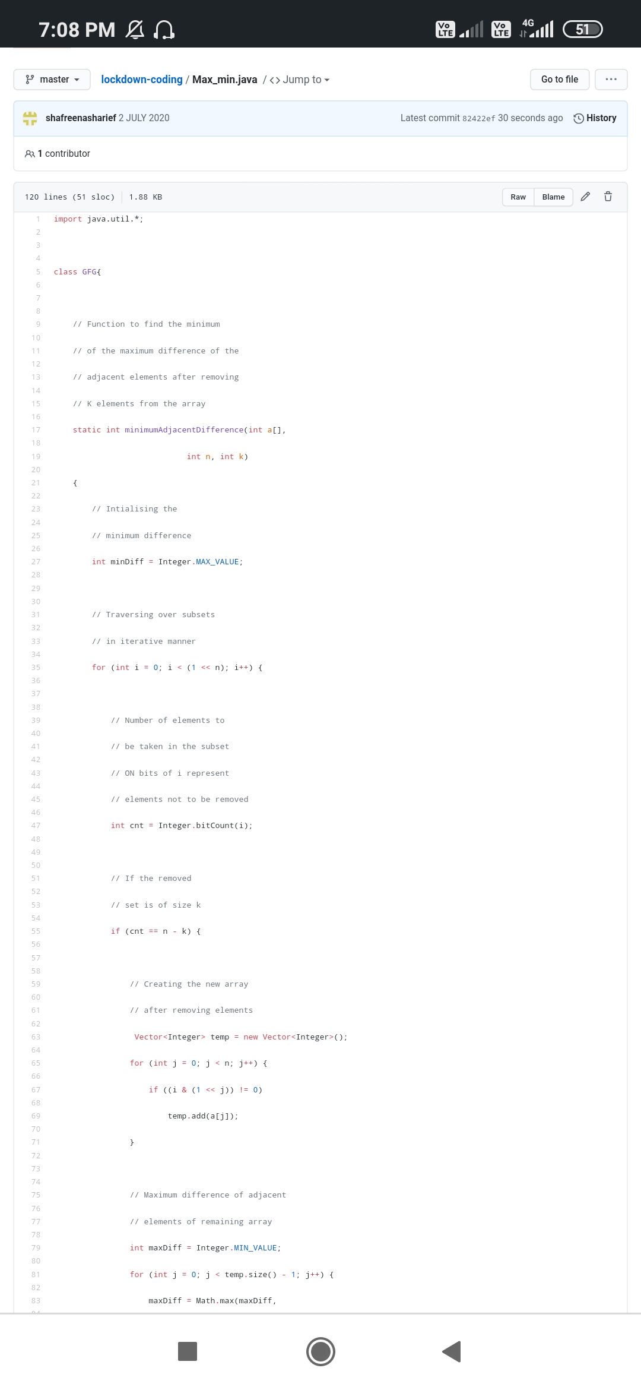

**EXTRA ACTIVITIES**:

Today I have attended the webinar on "**C++**” by Ms.shruthi shetty CSE department, AIET. The session was very interesting. There was assessment conducted based on the webinar.

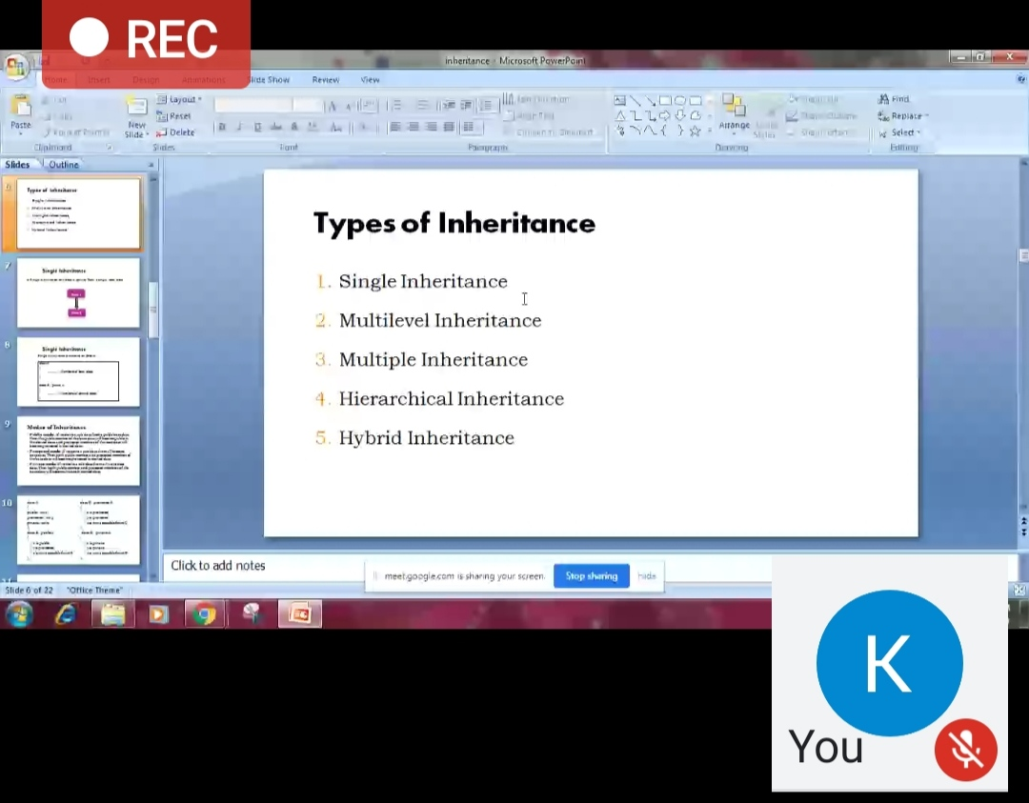

**SOLUTION** : I have uploaded the solution of the above 1 coding problems in my GitHub repository.

http://shafreenasharief / lockdown-coding

[http://shafreenasharief / locked-down--certification-course](http://shafreenasharief / locked-down--certification-course" \o "http://shafreenasharief / locked-down--certification-course)

[http://shafreenasharief / Daily\_Report](http://shafreenasharief / Daily_Report" \o "http://shafreenasharief / Daily_Report)